Weather Vane Application Project Plan

Place holder for cover page

Table of Contents

1. Project Summary 2

2. Project Organizational Structure 2

3. Scope Management Plan 4

4. Schedule Management Plan 5

5. Cost Management Plan 6

6. Quality Management Plan 8

7. Communications Management Plan 8

8. Risk Management Plan 9

9. Procurement Management Plan 10

10. Technical Process Plan 15

11. Appendix A 17

12. Appendix B 18

13. Appendix C 19

14. Appendix D 21

15. Appendix E 22

16. Appendix F 23

17. Appendix G 24

18. Appendix H 25

19. References 26

# **1. Project Summary**

## **1.1 Problem, Purpose, and Solution**

When traveling, weather can often be overlooked. This is especially true when traveling through multiple locations, and when the distance between locations becomes greater. Group1 Enterprises goal is to create an application that will gather all this data and forecasting in one place and help to organize and predict the weather affecting one’s travel. The application will use this information to suggest days that are best for traveling on the given route, along with suggestions on appropriate clothing to pack. Group1 Entreprises' solution will be developed on a web-based application that will allow the user to input locations, or travel routes, and calculate the weather forecast for those locations to provide the best times to travel and appropriate clothing.

**1.2 Assumptions and Constraints**

It is assumed that the users will have a basic familiarity with navigating web, navigation and weather applications. It is also assumed that the user will be able to use a simple graphical interface designed for inputting locations and selecting options from a menu.

The constraints will be that the user is accessing the application from a desktop or laptop and mobile devices may not be supported. The application will also only cover the geographic location of the continental U.S. and the API’s being used will need to be available.

# **2. Project Organizational Structure**

This project’s organizational structure is split into several different units. The overall structure is led by the Project Manager, and each unit consists of a leader responsible for the management of that section. However, it is important to note that all team members are flexible and responsible for multiple duties throughout all units.

## **2.1 Roles and Responsibilities**

### **2.1.1. Project Manager — Andres Danter**

The Project Manager is responsible for acting as a liaison between the team and upper management (professor), including communication between teammates and unit leads. Additionally, the Project Manager is responsible for scheduling and ensuring that all deliverables are completed and submitted on time, as well as organizing and recording all necessary forms of contact and conversation among the team.

### **2.1.2. Requirements Manager — Justin Middleton**

The Requirements Manager is responsible for the organization of all documentation and works with the Project Manager, the client, and all team members to ensure that all deliverables meet the requirement in the statement of work.

**2.1.3. Test Director — Helen Natnael**

The Test Director is responsible for creating testing scenarios to ensure that all requirements for the software are met. Additionally, the Test Director is responsible for carrying out these scenarios and identifying any defaults in the program, as well as maintaining documentation of these tests and directing developers towards the issue that requires attention.

### **2.1.4. Software Designer — George Shalhoub**

The Software Designer is responsible for creating the design of the program in accordance with business, mathematical, and scientific principles that correlate with the client’s request. Additionally, the Software Designer is responsible for working with the Project Manager, and all developers to create a final, functional product as requested by the client.

### **2.1.5. User Experience Manager— Justin Middleton**

The User Experience Manager is responsible for managing the project from a front-end perspective as requested by the client. This involves working with the Software Designer and Project Manager to ensure that the front-end development meets the project’s requirements by closely assessing the development process to ensure that the program is being built to fulfill the requirements.

# **3. Scope Management Plan**

## **3.1 Scope Statement**

The aim of the Weather Vane application is to provide the user with weather information and suggestions that may affect their travel plans. The scope of the application will be limited to weather as it relates to travel destinations.

## **3.2 Requirements Identification and Modification** All application requirements were provided and documented by the project sponsor prior to the initiation of planning and design. Should the sponsor desire modification of these requirements, the Project Manager’s approval will be required after consultation with designers and/or developers. Due to timeline restrictions, significant modifications will not be possible.

**3.3 Work Breakdown Structure**  
  
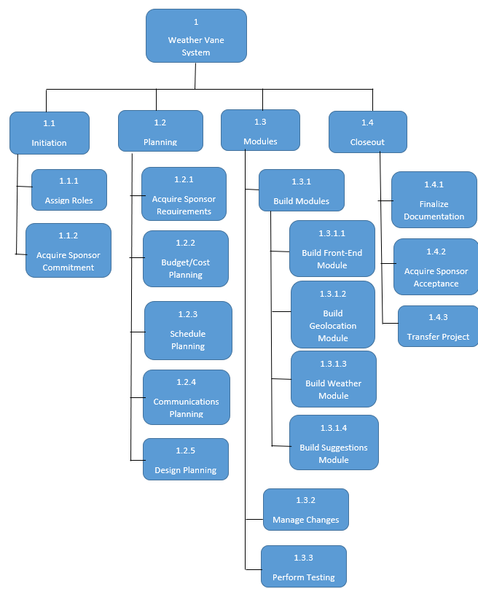

**3.4 Sponsor Acceptance**  
 Upon completion of the application, the sponsor will be provided a demonstration of all functionality. The sponsor will be given a trial period, not to exceed 10 days, before acceptance or rejection is expected. The sponsor will ensure all requirements have been met and the system is functioning properly in the local environment. The sponsor will sign a formal acceptance letter before project closeout.

## **3.5 Scope Control** All actions and effort will focus on the accomplishment of the stated goals, objectives, and requirements. This project is restricted by tight timeline constraints and therefore additional services, features, and functions will not be pursued.

# **4. Schedule Management Plan**

The Weather Vane application will take 8 weeks from design and development to deployment. Group1 Enterprises will be following a strict schedule to meet that deadline. To assure the team doesn’t fall behind, an Assignment Schedule was created (see Appendix C). The Assignment Schedule is an easy to follow weekly planner that identifies the team member leading the topic and its due date.

# **5. Cost Management Plan**

## **5.1 Introduction**

Group1 Enterprises Cost Management Plan for the costs on the Weather Vane application will be managed throughout the project’s software development lifecycle (SDLC). This document sets the format and standards by which the project costs are measured, reported and controlled. The Cost Management Plan:

* Identifies who is responsible for managing costs;
* Identifies who has the authority to approve changes to the project or its budget;
* How cost performance is quantitatively measured and reported upon;
* Report formats, frequency and to whom they are presented.

During the monthly synchronization meeting with upper management and the Project Sponsor and the Project Manager shall review the project’s cost performance, fund obligations, accruals and expenditures to ensure execution is meeting defined benchmarks for the preceding month. The Project Manager is responsible for managing and reporting on the project’s cost throughout its software development lifecycle, cost deviations, de-obligations, and presenting the Project Sponsor with options for getting the project back on budget. The Project Sponsor has the authority to make changes to the project to bring it back within defined benchmarks and budget.

## **5.2 Cost Management Approach**

Costs for the Weather Vane application shall be managed at the fourth level of the Work Breakdown Structure (WBS). Control Accounts (CA) will be created at this level to track costs incurred by individual developers. Earned Value calculations for the CA’s will measure and manage the financial performance of the project. Although activity cost estimates are detailed in the work packages, the level of accuracy for cost management is at the fourth level of the WBS. Credit for work will be assigned at the work package level. Work started on work packages will grant that work package with 50% credit; whereas, the remaining 50% is credited upon completion of all work defined in that work package. These work packages will have cost variance thresholds of ± 10% and of ± 20%. Once a variance reaches ± 20% it will require immediate corrective action by the Project Manager.

## **5.3 Measuring Project Costs**

Performance of the Weather Vane application will be measured using the Earned Value Management system. The following four Earned Value metrics will be used to measure projects cost performance.

* Schedule Variance (SV)
* Cost Variance (CV)
* Schedule Performance Index (SPI)
* Cost Performance Index (CPI)

|  |  |  |
| --- | --- | --- |
| **Performance**  **Measure** | **Yellow** | **Red** |
| **Schedule**  **Performance Index (SPI)** | between 90% - 80% or between 110% - 120% | less than 80% or greater than 120% |
| **Cost**  **Performance Index (CPI)** | between 90% - 80% or between 110% - 120% | less than 80% or greater than 120% |

## **5.4 Reporting Format**

Reporting for cost management will be included in the monthly project status reports. The Monthly Project Status Report shall include a section labeled, “Cost Management”. In this section, the Earned Value Metrics from the preceding month will be displayed. All cost variances outside of benchmarks in the Cost Management Plan will be addressed; to include all mitigations taken. Finally, Change Requests which are triggered based on deviations from defined benchmarks will be identified and tracked in the Project Monthly Status Report.

## **5.5 Cost Variance Response Process**

The Control Thresholds for this project is a CPI or SPI of less than 20% or greater than 120%. If the project reaches one or both of these Control Thresholds, a Cost Variance Corrective Plan of Action & Milestones is required. The Project Manager will present the Project Sponsor with multiple Courses of Action (COAs) to mitigate the variances within five business days. Within three business days from when the Project Sponsor selects a COA, the Project Manager shall present the Project Sponsor with a formal Cost Variance Corrective Plan of Action & Milestones. The Cost Variance Corrective Plan of Action & Milestones shall detail the necessary corrective measures to bring the project back in defined benchmarks and the milestones by which the effectiveness of the actions in the plan will be measured. Upon acceptance of the Cost Variance Corrective Plan of Action & Milestones, it will then become part of the project plan and the project will be updated to reflect this.

## **5.6 Cost Change Control Process**

The cost change control process will follow established policy detailed in the change request process. Approvals for project budget/cost changes must be reviewed by upper management and approved by the project sponsor.

## **5.7 Project Budget**

Given that all team members of the Group1 Enterprises have agreed to voluntarily dedicate their time towards the creation of the Weather Vane application, and given that all resources acquired will be open source, the cost of this project will be $0.00, which reduces the need for a project budget.

# **6. Quality Management Plan**

Group1 Enterprises' goal is to create an application that will gather data and forecasting in one place and help to organize and predict the weather affecting one’s travel. The plan will address quality planning, quality assurance, and quality control. The individual team member has a particular task they will tackle. We will meet twice a week to address the project's progress and any changes to the original plan according to the feedback we receive from our weekly submission. The Test Director will manage the application quality control by identifying the schedule cost, test cases, and acceptance criteria in week three. The Requirements Manager will provide in week two the requirement specification, and in the subsequent weeks, it will include the Change Management Plan and Traceability Matrix.

# **7. Communications Management Plan**

**7.1 Communication Plan**

|  |  |  |  |  |
| --- | --- | --- | --- | --- |
| Communication | Medium | Frequency | Goal | Owner |
| **Project Team** | | | | |
| Project Status | Slack | Weekly (Monday) | Review status of project modules and discuss details of deliverables for the week | Project Manager |
| Deliverable Consolidation | Slack | Weekly (Friday) | Discuss consolidation details for deliverables and any issues or delays | Project Manager |
| Task Review | Slack | Weekly | Discuss feedback from deliverables submitted the prior week | Project Manager |
| Final Product Demonstration | Virtual | At end of project | Demonstrate and explain all functionality to project sponsor | Project Manager |
| Issue Resolution | Call/text | As needed | Resolve issues that could delay or prevent on-time deliverable submission | All |
| **Project Sponsor** | | | | |
| Deliverable Submission | UMGC Submission Folder | Weekly | Provide project status update and present tentative deliverable | Project Manager |
| Final Product Demonstration | In person | At end of project | Demonstrate and explain all functionality to project sponsor | All |
| Feedback | UMGC Discussion Board | Weekly | Receive feedback on weekly deliverables | All |

# **8. Risk Management Plan**

The first step the team will take toward risk management is identifying all possible risks and planning the procedure to avoid the risks. This requires tracking potential changes to risk factors along the development process, as well as identifying solutions for any risks that may rise. In the case of any risk rising, the team will immediately report to the Project Manager, who maintains documentation of all risks and solutions throughout the development process.

To avoid risk in scope, the client will agree to the terms of development, which will be followed by the development team.

To avoid risk in communication and scheduling, all team members have agreed to dedicate eight weeks of their time to the development of the project and agreed upon a means of communication, as well as a flow of communication in order to direct any conversation towards the right channel.

To avoid quality risk, the development team has established certain requirements, such as frequent and clear communication, observing and following milestones and progress, and constant coordination between all team leads to ensure requirements are met on all ends of the development process. Further information is available in the Risk Register (Appendix G)

# **9. Procurement Management Plan**

## **9.1 Introduction**

The Procurement Management Plan sets the procurement framework which the Weather Vane project will follow. This document shall serve as a guide for managing procurements throughout the software development life cycle of the EPS project and will be updated as acquisition needs change. This plan identifies performers and the items and/or services that will be procured from them, the types of contracts to be used in support of this project, i.e., Indefinite delivery/indefinite quantity (IDIQ) contracts and/or Support Service Contracts, the contract approval process, and decision-making criteria. Other items included in the procurement management plan include: procurement risks and procurement risk management considerations; how costs will be determined; how standard procurement documentation will be used; and procurement constraints.

## **9.2 Procurement Management Approach**

The Project Manager shall provide project oversight and management for all acquisition and procurement activities for the Weather Vane project. The Project Manager shall work with the project team to identify all items to be procured for the successful completion of this project.

## **9.3 Procurement Definition**

The following procurement items and/or services have been determined to be essential for the completion and success of the Weather Vane project. The following list of items/services, justification, and timeline are pending PMO review for submission to the Acquisition and Financing divisions:

|  |  |  |
| --- | --- | --- |
| **Item/Service** | **Justification** | **Needed By** |
| **Item A; Access to OpenWeatherMap API** | Needed for accessing weather data (forecasts, advisories) | 14SEP2022 |
| **Item B; Access to Google Maps API** | Needed to perform geocoding queries for locations provided by users and route information | 14SEP2022 |
| **Item C; Google Compute Cloud Resources** | Needed to host application web server and database | 14SEP2022 |
| **Item D; Domain Name for Application** | Needed to provide easy-to-remember public URL for application | 14SEP2022 |

In addition to the above list of procurement items, the following individuals are authorized to approve purchases for the Weather Vane project team.

**Name Role**

Name Project Manager

Name Lead Designer

## **9.4 Type of Contract Vehicles to be Used**

All items and services to be procured for the Weather Vane project will be managed under a sole-source contract awarded to Group1 Enterprises due to their expertise in the field.

## **9.5 Procurement Risks**

While all risks will be managed in accordance with the project’s risk management plan, there are specific risks which pertain specifically to the acquisition process which must be considered:

* Unrealistic schedule and cost expectations for performers
* Manufacturing capacity capabilities of vendors
* Conflicts with current contracts and vendor relationships
* Configuration Management for upgrades and improvements of purchased technology
* Potential delays in shipping and impacts on cost and schedule
* Questionable past performers
* Potential that final product does not meet requirements

## **9.6 Procurement Risk Management**

Project procurement efforts involve external organizations and potentially affect current and future business relationships as well as internal supply chain and vendor management operations. Procurement risks will be closely tracked along with other project risks and contingencies will be put in place whatever possible.

## **10. Technical Process Plan**

Group1 Enterprise will be using the standard business practice of the Software

Development Life Cycle (SDLC) to help develop and deploy the Weather Vane Application. SDLC will help to improve the development process, which will in turn maximize efficiency at every stage of development (Jevtic, 2022).

## **10.1** **Process Model**

Group1 Enterprises will use the SDLC agile model. This methodology provides a more flexible approach for product creation, decreases time for completion, and allows for a simplified implementation of dynamic requirements (Bestaieva, 2020). This will fit best with the projects 8 week timeline and constantly changing requirements.

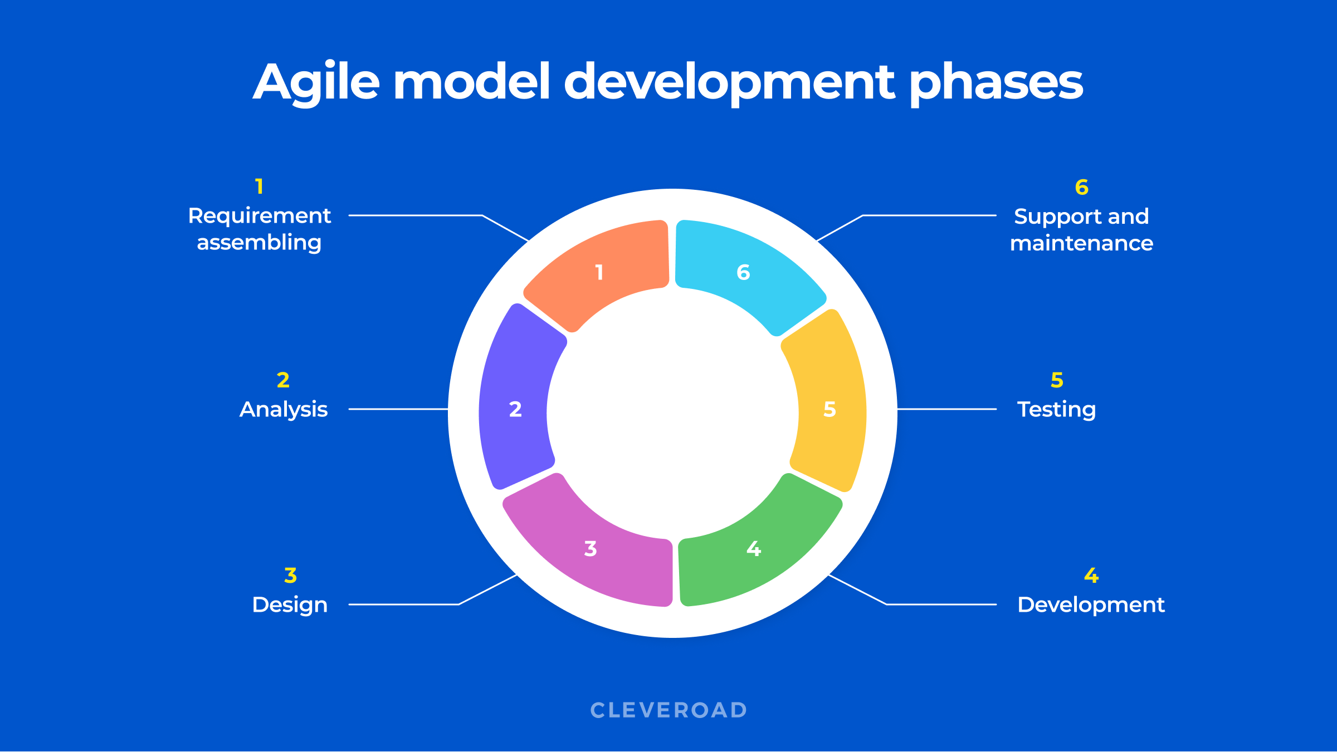

**Image from Bestajeva, 2020**

## **10.2** **Technical Requirements**

Group1 Enterprises will be utilizing the following tools and techniques for the development of the Weather Vane application:

* Language – Python, HTML, CSS, JavaScript
* Framework – Django, Bootstrap
* Database – MySQL or PostgreSQL
* Code repository – GitHub
* Documentation – Microsoft Word
* Communication – Slack, Zoom

Coding for the front-end will be in HTML and CSS to aid in the creation of the web-based application. The Bootstrap framework will be uploaded for ease of customizing our application. For the backend development, Python and the Django Web Application Framework will be used. Additionally, either MySQL or PostgreSQL will be used as a database to record necessary information from the application. GitHub will help the team collaborate with the code in a free and easy to use location. All documentation will be completed in Microsoft Word for the sake of compatibility and usability.

**Appendix A**

**Project Charter**

|  |
| --- |
| **Project Name:** Weather Vane |
| **Date:** August 17, 2022 |
| **Project Manager:** Andres Danter |
| **Project Sponsor:** Terry Mentzos |
| **Requested Completion Date:** October 11, 2022 |
| **Project Justification:** This technological solution will provide a web hosted Graphical User Interface (GUI) that will allow users to access it from any desktop computer. The application will allow the end user to enter one or more destinations, and it will provide weather forecasts for those destinations as well as any weather advisories, packing suggestions and alternative travel days. |

|  |
| --- |
| **Project Overview** |
| 1. Project Plan 2. Test Plan 3. Project Design 4. Phase 1 Source: classes 5. Phase 2 Source: methods 6. Phase 3 Source: user experience and modules 7. Final deliverable |

|  |  |  |  |
| --- | --- | --- | --- |
| **Approvals** | | | |
| **Title** | **Name** | **Signature** | **Date** |
| Project Sponsor | Terry Mentzos | (Email confirmation is acceptable in place of signature.) |  |
| Project Manager | Andres Danter |  |  |

**Appendix B**

**Project Team**

|  |
| --- |
| **Project Name:** Weather Vane |
| **Date:** Aug 17, 2022 |
| **Project Manager:** Andres Danter |

|  |  |  |
| --- | --- | --- |
| **Role** | **Name** | **Contact** |
| Project Manager (PM) | Andres Danter | adanter@gmail.com |
| Requirements Manager/User Experience (UX) | Justin Middleton | justindmiddleton@yahoo.com |
| Software Designer (SD) | George Shalhoub | shalhoubfive@gmail.com |
| Test Director | Helen Natnael | aanatnael@gmail.com |

**Appendix C**

**Statement of Work**

**Scope**

As agreed upon with the client, the contractor will provide the client with a single solution to improve users’ travel plans by integrating location and route information with weather data. This solution will come in the form of a web application, which users will access using a URL. The Weather Vane application will allow the user to enter one or more destinations, and the application will then provide weather forecasts, weather advisories, if any, and recommendations on what to pack and alternative travel days.

**Location of Work**

All work will be completed virtually, as the solution is software based and does not require in-person meetings.

**Timeline**

The timeline of work is between the dates of August 17, 2022, and October 11, 2022, with the final product to be delivered on October 11, 2022. The schedule of work is included in the delivered Project Plan, Appendix C.

**Acceptance Criteria**

The acceptance criteria as agreed upon with the client is as follows:

**Software and Hardware Requirements**

For this application, the client will require the following to run the program:

* A personal computer (PC or Macintosh)
* A web browser
* Internet connection

The information described above are the requirements agreed upon between the contractor and client. The contractor is required to fulfill all mandatory requirements by the scheduled finish date, and the client is required to review and accept the completed application based on its ability to successfully perform the mandated requirements.

**Appendix D**

**Schedule**

|  |  |  |  |  |  |  |
| --- | --- | --- | --- | --- | --- | --- |
| Week | Dates | Lead | Topic | Description | Due Date | Assignments Due |
| 1 | 8/17 - 8/23 | Everyone | Form Teams | * Get to know team members * Pick a topic | - | - |
| 2 | 8/24 - 8/30 | * Andres Dante   + Project Manager * Justin Middleton * Requirements Manager/ Technical Writer | Project Plan | * Outline Milestones * Delegate responsibility * Describe projects purpose * Identify the system specifications | 8/30 | Project Plan |
| 3 | 8/31 - 9/6 | * Helen Natnael   + Test Director | Users Guide and Test Plan | * Create test plan with a clear users’ guide * If appropriate create test data files | 9/6 | Test Plan  Peer Review 1 |
| 4 | 9/7 - 9/13 | * George Shalhoub   + Software Designer * Justin Middleton   + User Experience / Training Manager | Design | * Design a user interface and related structures * Finalize test case | 9/13 | Project Design |
| 5 | 9/14 - /20 | Everyone | Phase 1 Source | * Software Development | 9/20 | Phase 1 Source  Peer Review 2 |
| 6 | 9/21 - 9/27 | Everyone | Phase 2 Source | * Software Development | 9/27 | Phase 2 Source |
| 7 | 9/28 - 10/4 | Everyone | Phase 3 Source | * Software Development | 10/4 | Phase 3 Source |
| 8 | 10/5 - 10/11 | Everyone | Final Report | * Compile all Topics into a single document | 10/11 | Final  Peer Review 3 |

**Appendix E**

**Gantt Chart**

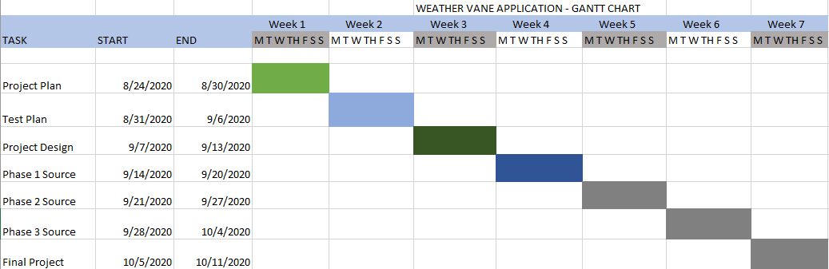

**Appendix F**

**Scope Baseline**

|  |  |  |  |
| --- | --- | --- | --- |
| Scope Baseline: Front-End | | | |
| System Requirements Checklist | Item | Status | Notes |
| Can the user enter a singular location by typing the name in a search bar? | 1a |  |  |
| Can the user select an option to add another route the list of routes? | 1b |  |  |
| Can the user enter multiple locations, up to ten, by typing the names in a search bar? | 1c |  |  |
| Does the application check if the location entered is within the United States? | 1d |  |  |
| Does the application allow concurrent user sessions? | 1e |  |  |
| Can the user enter a date and time? | 1f |  |  |
| Does the application require a start and end location to create a route? | 1g |  |  |
| Can the user select whether they want to create a route, get the weather forecast, or get a suggestion? | 1h |  |  |

|  |  |  |  |
| --- | --- | --- | --- |
| Scope Baseline: Geolocation | | | |
| System Requirements Checklist | Item | Status | Notes |
| Does the application successfully create a route between multiple locations? | 2a |  |  |
| Does the application show the entered location? | 2b |  |  |
| Does the application show a summary of the trip? | 2c |  |  |

|  |  |  |  |
| --- | --- | --- | --- |
| Scope Baseline: Weather | | | |
| System Requirements Checklist | Item | Status | Notes |
| Does the application display the weather for the location? | 3a |  |  |
| Does the application display the weather for every inputted location along a route? | 3b |  |  |
| Does the application show the weather for a location at the specified time and date? | 3c |  |  |
| Does the application show weather advisories for the given locations? | 3d |  |  |

|  |  |  |  |
| --- | --- | --- | --- |
| Scope Baseline: Suggestions | | | |
| System Requirements Checklist | Item | Status | Notes |
| Does the application display clothing suggestions based on the weather at the location? | 4a |  |  |
| Does the application display clothing suggestions based on the weather at multiple locations? | 4b |  |  |
| Does the application suggest different times to travel based on weather at specific times? | 4c |  |  |
|  |  |  |  |

**Appendix G**

**Risk Register**

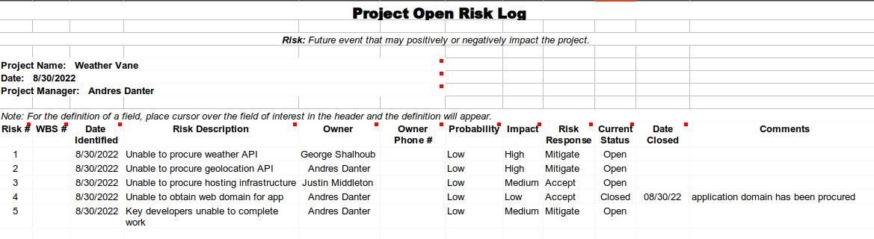

**Appendix H**

**Action Item Log**

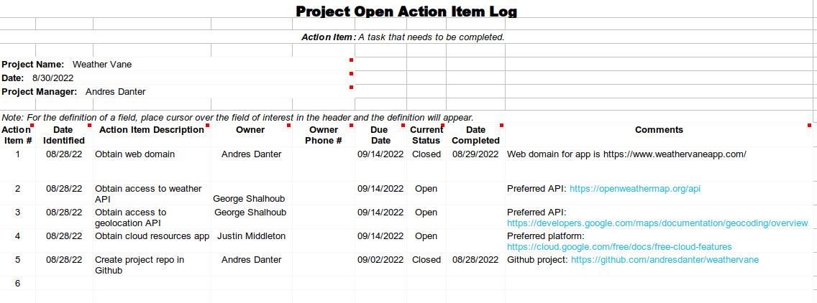

References

Bestaieva, D. (2022, August 5). *The Full Guide on Agile SDLC for 2022*. Cleveroad Inc. - Web and App Development Company. <https://www.cleveroad.com/blog/agile-sdlc/>

Jevtic, G. (2022, February 9). *What is SDLC? Phases of Software Development, Models, & Best Practices*. phoenixNAP Blog. <https://phoenixnap.com/blog/software-development-life-cycle#:%7E:text=Software%20Development%20Life%20Cycle%20is,%2C%20Test%2C%20Deploy%2C%20Maintain>.